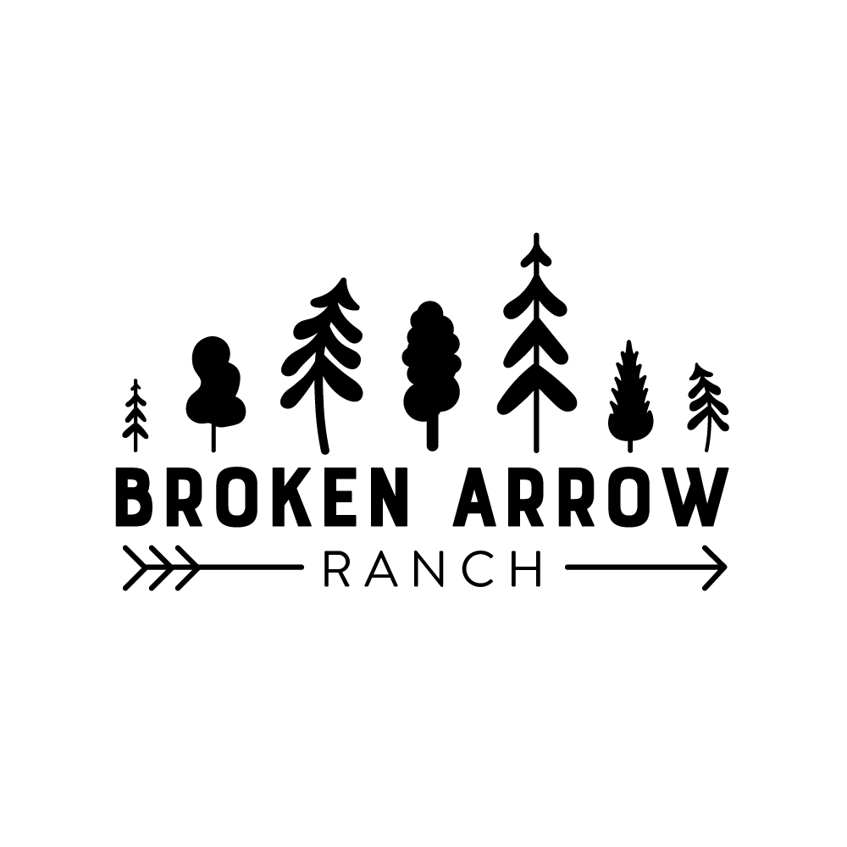

Howdy,

So you want to do some horseback riding. We are so excited to help you enjoy your week that we wanted to check in and make sure you wouldn't miss a minute of it. There are three things we require for you to safely participate in this activity: jeans, close-toed shoes, and a helmet (Don't worry, we provide helmets, but more on that later).

Let's talk about each item so you know what to bring and why:

Jeans - saddles can get hot in the sun and they can also pinch. (Ouch!) We also do trail rides and though we clear our trails, sometimes you can still scuff your knee or scrape your leg. Jeans help to protect you, so please make sure you pack full-length jeans (no capris, or cloth/stretchy pants)

Shoes - horses are big creatures and sometimes they don't know your foot is there when they are stomping flies or just walking. Also, sandals or other comfortable shoes, for example crocs, can get caught in the stirrup and are extremely dangerous. Riding boots are best, but we will take sneakers. Protect those toes!

Helmet - For safety, all riders are required to wear a helmet. We provide certified riding helmets but

we still need you to be prepared. The helmet must sit naturally over the skull to guarantee proper use. Ponytails, buns, braids, or any hairstyle that prevents the helmet from sitting naturally must be taken

down or you will not be able to participate in the activity. Thank you for reading this message so that you will be prepared to enjoy horseback riding at Broken Arrow Ranch!

We can’t wait to see you at the barn!

The Equestrian Staff